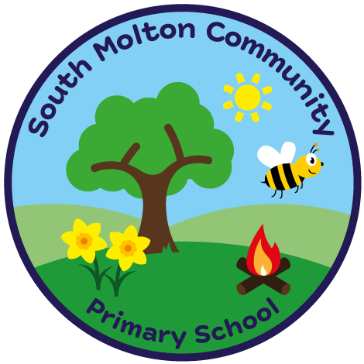
South Molton Community Primary School
Ofsted Number: 113168

BREAKFAST CLUB BOOKING FORM – SECOND HALF Summer term 2024

£3.00 per session 8.00am – 8.45am
Includes a healthy breakfast

Child/Children Name ………………………..………………..…..…….Class/Classes…………………….....

W / C | Monday | Tuesday | Wednesday | Thursday | Friday
03/06/2024
10/06/2024
17/06/2024
24/06/2024
01/07/2024
08/07/2024
15/07/2024
22/07/2024 |  |  | xxxxxxxxxxxxx | xxxxxxxxxxxxxx | xxxxxxxxxxxxx

Signed _______________________________

Completed booking forms and payment MUST be in advance, via ParentPay
Breakfast club fees are non-refundable.
Please drop off your child at the Hall.

South Molton Community Primary School
Ofsted Number: 113168

BREAKFAST CLUB BOOKING FORM – SECOND HALF Summer Term 2024

£3.00 per session 8.00am – 8.45am
Includes a healthy breakfast

Child/Children Name ………………………..………………..…..…….Class/Classes…………………….....

W / C | Monday | Tuesday | Wednesday | Thursday | Friday
03/06/2024
10/06/2024
17/06/2024
24/06/2024
01/07/2024
08/07/2024
15/07/2024
22/07/2024 |  |  | xxxxxxxxxxxxx | xxxxxxxxxxxxx | xxxxxxxxxxxxxx

Signed _______________________________

Completed booking forms and payment MUST be in advance, via ParentPay
Breakfast club fees are non-refundable.
Please drop off your child at the Hall.

