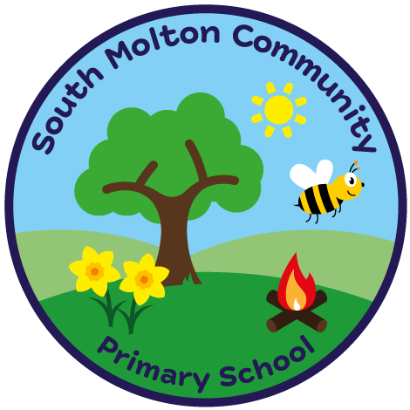
South Molton Community Primary School
Ofsted Number: 113168

BREAKFAST CLUB BOOKING FORM – FIRST HALF AUTUMN TERM 2024

£3.00 per session 8.00am – 8.45am
Includes a healthy breakfast

Child/Children Name ………………………..………………..…..…….Class/Classes…………………….....

W / C | Monday | Tuesday | Wednesday | Thursday | Friday
02/09/2024 | XXXXXXXXXXX | XXXXXXXXXXXX | XXXXXXXXXX
09/09/2024
16/09/2024
23/09/2024
30/09/2024
07/09/2024
14/09/2024
21/09/2024

Signed _______________________________

Completed booking forms and payment MUST be in advance, via ParentPay
Breakfast club fees are non-refundable.
Please drop off your child at the Hall.

South Molton Community Primary School
Ofsted Number: 113168

BREAKFAST CLUB BOOKING FORM – FIRST HALF AUTUMN TERM 2024

£3.00 per session 8.00am – 8.45am
Includes a healthy breakfast

Child/Children Name ………………………..………………..…..…….Class/Classes…………………….....

W / C | Monday | Tuesday | Wednesday | Thursday | Friday
02/09/2024 | XXXXXXXXXXX | XXXXXXXXXXX | XXXXXXXXXXX
09/09/2024
16/09/2024
23/09/2024
30/09/2024
07/09/2024
14/09/2024
21/09/2024

Signed _______________________________

Completed booking forms and payment MUST be in advance, via ParentPay
Breakfast club fees are non-refundable.
Please drop off your child at the Hall.

